
Tswelelopele

Kgolo go ya ka ponatshego- Growth through transparency

September 2015

Issue 3 • Volume 3

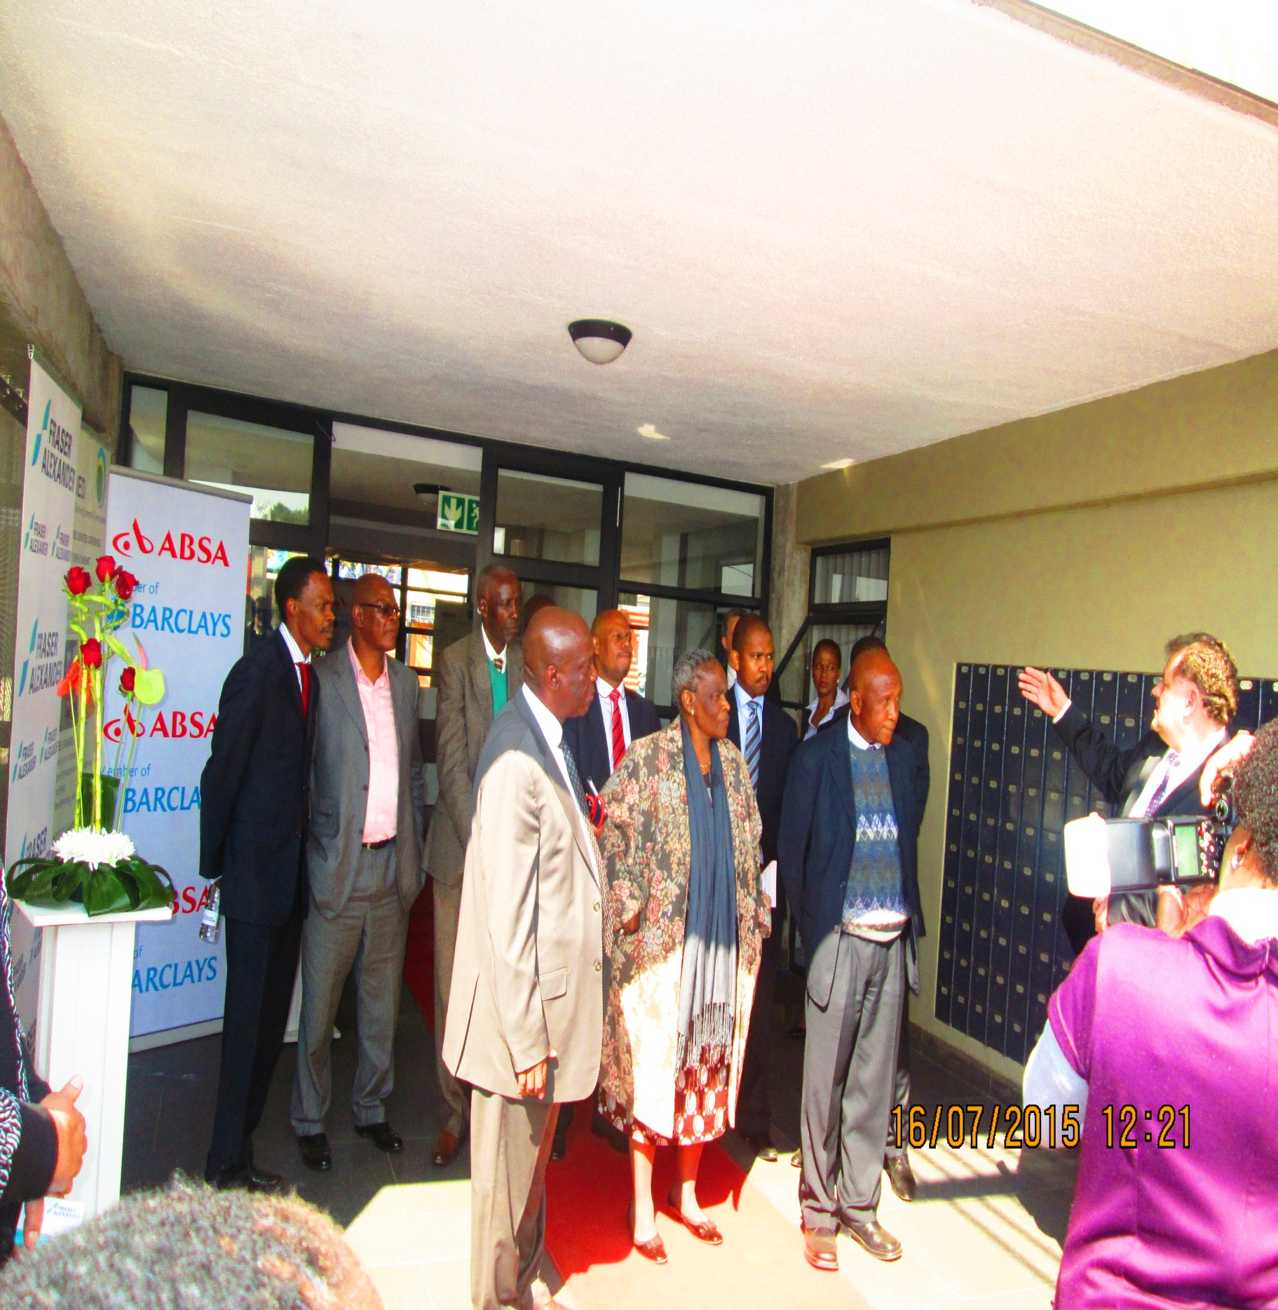
- Editor’s Note
- SMME of the Month
- RBED/ABSA/Frazer ED Center Launch
- Cooperatives
- ABSA, Celebrating Woman’s Day
- Business tips for beginners
- Raiz Corp
- Business Quiz
IN THIS ISSUE:


EDITOR’S NOTE

The opening of the newly established Enterprise Center (ED) has become such an enthusiast to our local SMMEs and Rustenburg as a whole. We are very delighted to have ABSA Enterprise and Frazer alexander joining the HUB.

There is nothing as exciting as helping the community, attending to their business needs and get the positive response. The SMMEs visits to the center on a daily basis with a confident response make us so proud that we are reaching the goal as promised to the community, by contributing towards achievement of the Economic Development objective of the RBN’s Vision 2020.

My wish as RBED colleague is to see our local SMMEs growing for the better, creating opportunities, developing millionaires and poverty eradication in Phokeng.

Rre Ian please add …

Editor: Tebogo Sedumedi

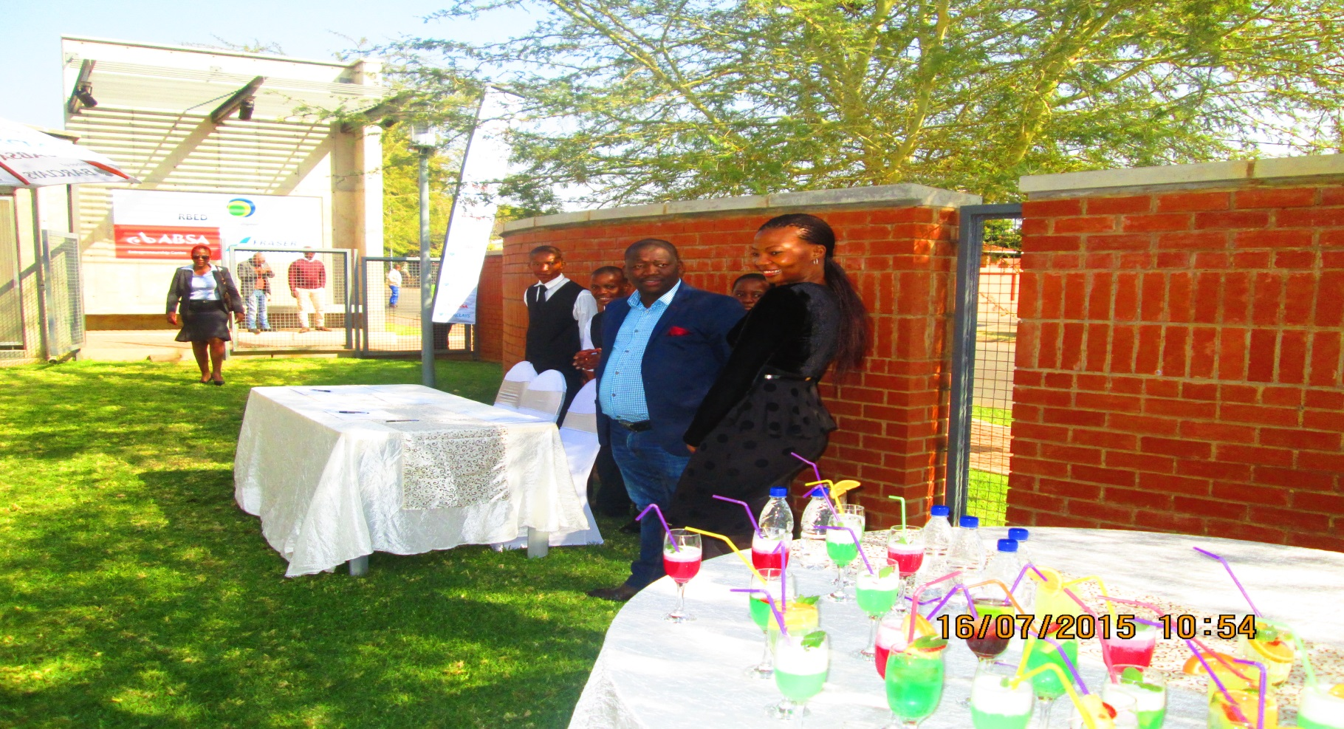
RBED/ABSA/FRAZER

SMME OF THE MONTH – Kagiso Mamogopodi
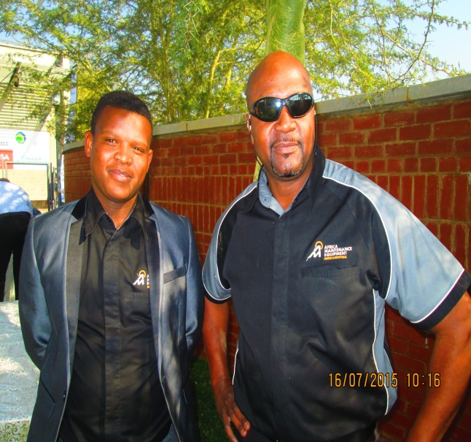
Q: Tell us about yourself/ who is Kagiso?
A: I am a 25 years old gentleman residing in Kanana village one of the 29 villages of the royal Bafokeng Nation. I am an Electrical Engineer Graduate from the Vaal University of Technology.
I completed my in-service training through a company called Wegezi Power Holding (INVICTA Holdings Group Company) which afforded me an opportunity to oversee a project for Bafokeng Styl Drift mine at XD Jinan Transformers in China.

Q: When did you realise that you can start a business?
A: Since I was at Varsity I always had a dream to build my own legacy, it gives me great pleasure to be partnering with Mandirk in the distribution of a diversified portfolio of products and services for the Platinum sector. The Mandirk localization initiative provides me with huge scope for personal growth and development.
Q: What motivated you to start your own business?
A: The products and services range MANDIRK will be distributing through Africa Maintanance Equipment Rustenburg, made me realize a huge potential for the business growth of AME in the Rustenburg region. I see a significant development in my communication skills, adaptability, awareness and leadership contribution to the business and community.
Q: What makes you a successful business person?
A: The enthusiasm to achieve more in everything that I do. Patience in every aspect of my life. The eagerness to ask when I do not know or understand something. Passion to engage to gain knowledge and increase the level of communication. Passion to succeed in every aspect of the business environment I am exposed to.

Q: What are some of the challenges you faced when you started your business?
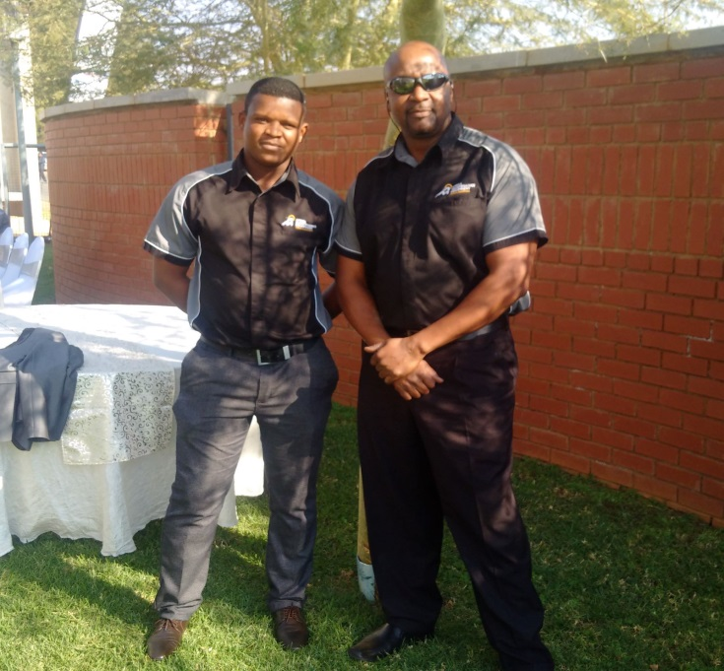
A: I was faced with the following: I needed to understand the type of products am selling. I secondly needed to build my customer base relationship. I needed to identify my core potential clients and those that needed more focus. I needed to know market trends. I needed to know my competitors potential, strengths and weaknesses.
Q: What contributes to the challenges that can result in failure within a business?
A: The absence of concise planning, organizing, leading and controlling as key deliverables for competitive advantage.

Q: If you have to advise an individual interested in starting a business what would you say?
A: For anyone with entrepreneurial aspirations, I recommend that they start by networking with peer business people and organizations before they commit to a start-up of their own business. They should ask questions and do everything they can to make sure they are tackling the right business for the right reasons. A well thought out risk analysis of the new venture should be the main prerequisite before establishment and operation of a new venture.

Q: What are your aspirations?
A: To be a highly motivated, enthusiastic leader with exceptional, proven performance.
To be an experienced leader with an emphasis on employee development and retention.
To have excellent coaching skills. To be committed to provide a pleasant, sales orientated environment.

Q: What are your plans for the future? A: My primary goal is to make a contribution to society by creating jobs and supporting Socio-Economic Development initiatives within the communities where AME operates. Setting an example for young locals, showing that it doesn’t matter where you come from or how old you are, if you believe in the lord and yourself you can achieve the aspirations of your heart. To be the best role model entrepreneur through the acquisition of business skills, knowledge, training programs and mentorship.
SMART PROCUREMENT BOFE
Some of RBED local SMMEs attending Business Opportunities and Franchise Expo.
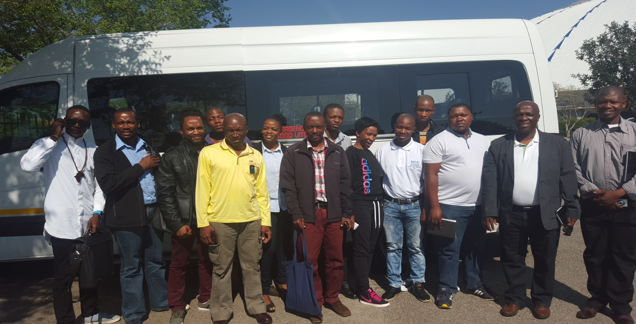
The Business Opportunities and Franchise Expo 2015 brings together leading Business Opportunities, Franchise options and Business Support Service companies to an audience of successful and aspirant entrepreneurs who have the motivation and capital to invest in a new business venture.

Sponsored by RBED

RBED/ABSA/FRAZER - ED Centre Launch

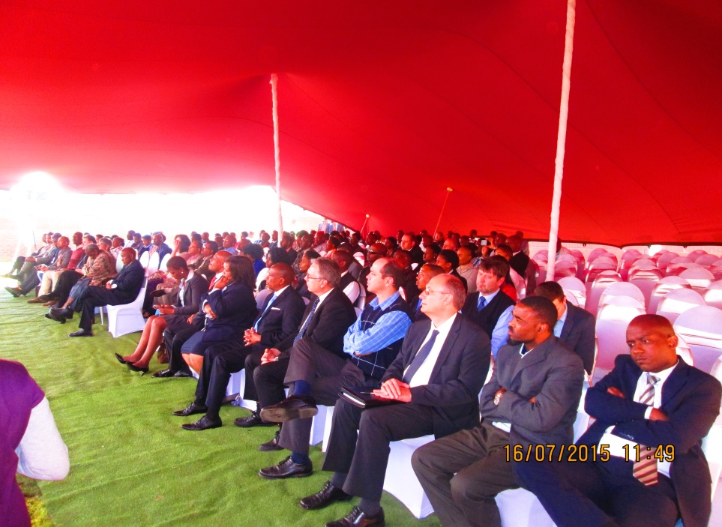
PARTNERSHIP BETWEEN RBED, ABSA AND FRASER ALEXANDER TO THE ADVANTAGE OF LOCAL SMMEs
Royal Bafokeng Enterprise Development in collaboration with ABSA Enterprise and Frazer Alexander was launched officially on the 17th July 2015. The centre is aimed at changing the lives of local SMMEs to become the best in their business endeavours and the community.
SMMEs can access funding through ABSA Enterprise Development with the money set apart in partnership with RBED to help them grow and become ecological. The entrepreneur centre is visualised to be an active and animated hub full of activities where entrepreneurs can come and get-up-and-go with their work, seeking help and advises and also access opportunities.
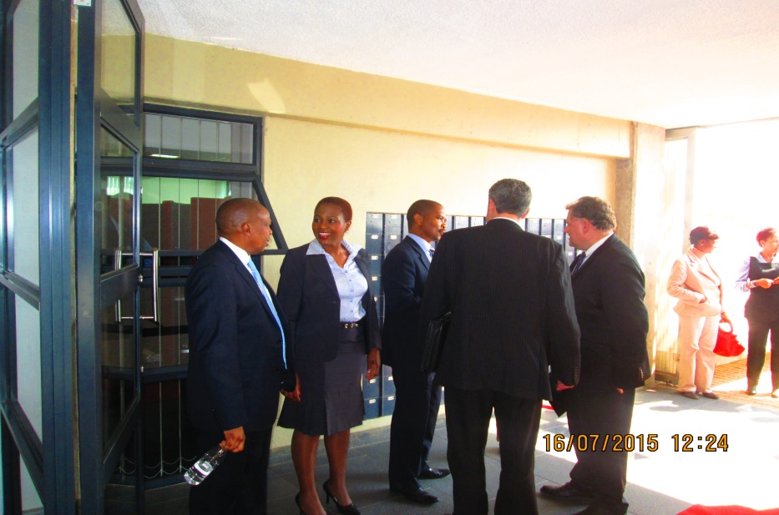
Frazer Alexander’s team will be coming to assist the Bafokeng SMMEs by directing new applicants into supply chain and allowing them access to procurement opportunities.
SMMEs who are registered in RBED database will have the opportunity to access the following:
- Boardroom bookings
- Training rooms
- Free internet access in the computer lab

FRASER ALEXANDER

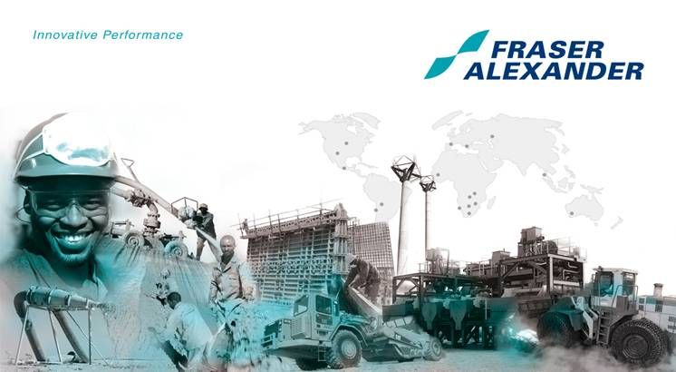

05 Mar. 14
CSI Initiative: FAs Renewable Energy Concept
“With the increase in population and the growth of Rustenburg comes a greater demand for Electricity. New residential areas as well as new businesses need electricity. This, therefore, means that Eskom, the South African public enterprise responsible for provision of Electricity, needs to widen supply to accommodate an ever – growing requirement. This is calls for, amongst other, the building of new power stations and extension of power lines to reach new development areas” Sagoagoe: 09 November 2013

In response to the growing need of electricity, Fraser Alexander in collaboration with relevant stakeholders is embarking o a Renewable Energy Pilot Project that will ensure that disadvantage backgrounds have alternative electrification for their households and address the issues to reduce consumption.
The initiative was born from Mmemogolo Moletlegis’ idea, when she expressed her interest in finding an alternative solution for her community by cultivating Bamboo Trees to produce electricity.
Renewable Energy comes either directly or indirectly from the Sun. Sunlight, or Solar Energy can be used directly for heating and lighting houses and other buildings to generate electricity. The Solar Energy technologies uses that suns energy and light to provide heat, light, hot water, electricity and cooling of homes and business.
With the help of stakeholders such RBED, Councillors and Headmen and other entities, Fifty (50) beneficiaries have been identified. The project is fully funded and driven by Fraser Alexander using an International Company, Fortune CP, partnered with a local SMME identified and vetted by RBED, namely KAGISO PRODUCTIONS.
With a Solar Panel System, a household can easily reduce its electricity consumption and realistically reverse the cost by generating more energy being consumed.....

COOPERATIVES

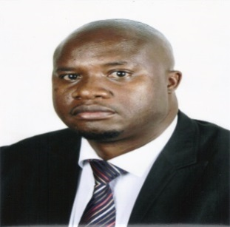
Youth can benefit from cooperatives

With

Antony Jongwe

The Royal Bafokeng Administration (RBA) commissioned research to investigate youth unemployment in the Royal Bafokeng Nation. This culminated in a report entitled “Youth Unemployment in the Royal Bafokeng Nation – Quantifying Youth Unemployment and Documenting Youth Perceptions on Barriers to Labour Market Entry. Royal Bafokeng Administration. Phokeng” (Moyo, 2015).

The report notes that 44% of the youth are unemployed with a further 11% classified as being economically inactive. Only 46% of the youth are employed. The report further notes that the majority of the unemployed youth are mostly interested in obtaining permanent full-time employment. Where self-employment and entrepreneurship were suggested in the report, the youth raised concerns about their ability to do so such as lack of funding and inadequate business skills to run those businesses successfully.

However, the report did not explore cooperatives as a tool to address youth unemployment in Royal Bafokeng Nation (RBN). This is surprising considering that the International Labour Organisation (ILO) has identified the cooperative model of enterprise as a viable source of youth employment, particularly in ‘rural and urban areas and for persons of all academic and skill levels including recent graduates who have limited prospects of finding jobs’ (ILO, 2012:2).

Locally, the National Youth Development Agency (NYDA) has also shown its confidence in the power of cooperatives do address the high youth unemployment rate of 28% in the North-West Province (Stats SA, 2010). For example, the NYDA North West channelled R1.5 million into the development of the Bana Ba Kgwale Cooperative in conjunction with AFF and Pick n Pay in the 2010/2011 Financial Year.

Yet, there is not much information available on the perceptions of Bafokeng youth towards cooperatives. The ILO study entitled “A better future for young people: What cooperatives can offer” identifies a number of benefits for the unemployed youth which are associated with cooperatives.

Cooperatives enable young people to pool often limited financial resources with knowledge in an enterprise that can respond to nearly every need and productive activity. The cooperative form of enterprise is an option for young people as it has low capital requirements, limited liability, and in cases where members are also employees, the flexibility of self-employment. Cooperatives also facilitate school-to-work transition by providing on-the-job training to young people through internship or apprenticeship programmes.

In conclusion, the scale and impact of the current youth employment crisis on the future of young people and societies is a call for immediate action. The RBA is commended for commissioning a study on youth unemployment. There is need for further research on how cooperatives can be used in the RBN to benefit youth as illustrated by the research findings of the ILO.

Antony Jongwe researches on forms of cooperation that exist in enterprising communities. He also consults with various stakeholders on the matter. Contact him via e-mail: consultgws@gmail.com or phone: +27717873144

ABSA – Celebrating Woman’s day
Harnessing the power of women entrepreneurs could unlock much-needed economic growth

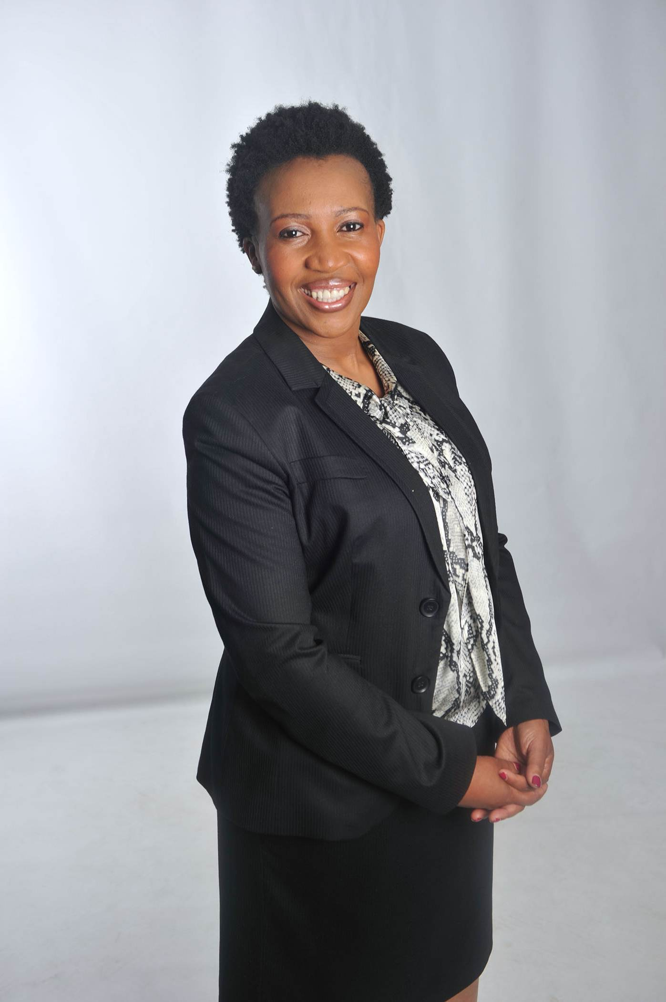
South Africa needs more women starting and running their own businesses, if the economy is to fire on all cylinders and create much-needed growth and employment. Despite the significant progress that the country has made over the past two decades in advancing the empowerment of women, more still needs to be done when it comes to women entrepreneurship. The world of business remains pretty much a man’s world.
Recent trends indicate that the number of self-employed women in South Africa is in fact in decline, which means the full participation of women in the economy is being eroded. At a global level, statistics show that while women make up about 50% of the world population and 40% of the global workforce, they own only about 1% of the world’s wealth. In comparison to men, women’s unemployment levels remain higher both in educated and less educated categories. Although these statistics are global, local figures tend to mirror these trends.
Women entrepreneurs in South Africa, however, still face more obstacles in starting their own businesses than their male counterparts. This is notwithstanding the fact that women generally bring certain unique abilities to entrepreneurship. We know that given the opportunity, women would invest most of their income into their families and communities. This means that putting more wealth in the hands of women could have a significant positive multiplier effect on the economy.
The multi-dimensional challenges that women continue to face include financing and credibility as business owners and managers. Access to finance and credit in particular remains a major constraint for many. Women – and rural black women in particular – continue to have a raw deal in this regard. They have difficulties accessing finance for various reasons, including poverty, limited employment in the formal sector, and cultural barriers to land and property ownership. Access to bank funding is also on average more restrictive for women-owned small and medium enterprises.

Added to these, other barriers include socialisation networks and practices, family roles and possible lack of business contacts. Social conventions, for example, dictate the roles of men and women in the household, workforce and society. These conventions tend to have a negative effect on the ability of women to start and grow their businesses. These disadvantages, therefore, can explain higher failure rates and lower growth rates for women-owned businesses.
Indeed it is not true to suggest that it is all doom and gloom for women. On a positive note though, a number of women have made major inroads in business and their impact is just slowly beginning to be felt. For example, there are many women in Africa who have gone beyond making handicrafts or running spazza shops or taverns to becoming successful business owners with vast empires in various sectors of the economy. Their successful ventures have translated into high financial returns and created many jobs. For these women, business success has not always come easily. Most of them remain the exception rather than the norm, and their success has come largely through a combination of hard work and unbridled tenacity and sometimes sheer luck.
Despite the inequalities between men and women in business, there is lot that can be done to build a better future for female entrepreneurs. The challenges women face provide opportunities for women themselves, various stakeholders, including the NGOs, government, financial institutions and other private sector players in addressing the issues. We all need to become more committed to fostering an environment that supports women entrepreneurs.
At Barclays Africa we are doing our bit in trying to remove the obstacles to business opportunities and economic participation that women face. We are doing this partly by providing various forms of both financial and nonfinancial support. Through a number of initiatives we are also identifying and building networks of women entrepreneurs to empower them to successfully own and operate their businesses. Through our annual “Women in Business Series”, for instance, we are bringing together a strong circle of female mentors to accelerate women-led entrepreneurship across all sectors.
Although our entrepreneurship development programmes are designed to support both men and women, young and old, we find that support from peers as well as more organised support and formal entrepreneurship activities, are important for everyone, but particularly so for women.
At a much broader level, we should consider finance facilities that are dedicated to women-owned SMEs, with commitments to help finance new projects in areas where there is great potential empower women and grow the economy. The idea is to increase access to capital for women-owned businesses. Barclays Africa already has such a facility in the form of its Women Development Fund.
We believe such efforts could enable more women entrepreneurs to affordably invest in their businesses. In the long run, this would create new jobs and significantly contribute to economic growth.
By Happy Ralinala,
Head of Absa Business Banking

The opening of Phokeng Multi Recycle (PMR)  Phokeng scrap metal was launched on the 12th June 2015 at Lefaragatlha village. The center is operating under the leadership of Mr Thabo Pitsoe.  The company offer the following services:  - Waste  - Recycle labels  - Yard debris  - Hazardous material collection | 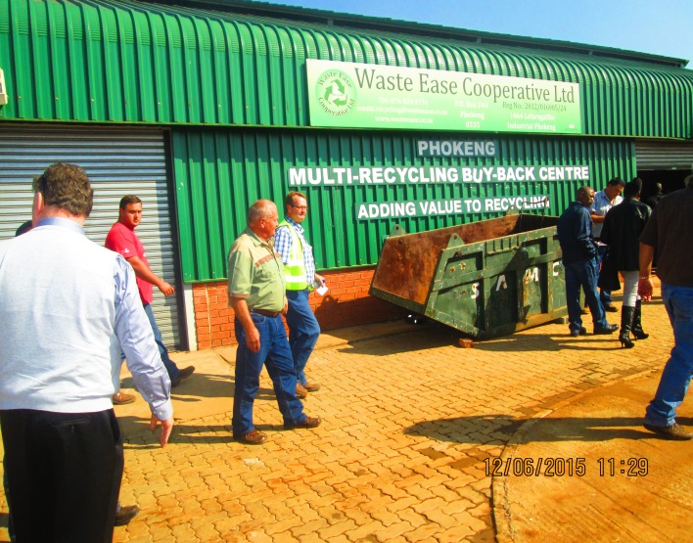

Business tips for Beginners

Getting Started

What do I need before I get started?
Before you get started find out if people are interested in buying your products or services and who your competitors are and whether the market can sustain your business. Conduct some research to see whether your idea is really feasible. This will involve gathering, analysing and evaluating information to help you formulate your business goals.
Am I ready?
Are you ready to venture into business? Operating a small business is not just about working for yourself, it's also about having the necessary management skills, industry expertise, technical skills, finance and of course a long-term vision to grow and succeed.
How can I get advice and support?
You can take advantage of a broad range of advice and support offered by the Australian Government. These services include information and advice on starting and expanding a business, obtaining funding and training.
What type of business should I start?
Do you want to start a new business or would it be better to buy an already established one? Starting a new business requires a great deal of time and money. You’ll need to research the market, raise finance, establish contacts, find a location and maybe hire new staff. Buying an established business or a franchise has the advantage that operations are already in place. The premises and stock, customer base, suppliers and income stream are already established.
Which business structure should I choose?
What type of business structure will you use? Will you be a sole trader, in a partnership, a company or a trust? There are advantages and disadvantages to consider for each. Choosing your business structure is an important decision, so you need to investigate each option carefully.
How do I choose a business name?
Choosing the right name will help ensure you’re creating the right image for your business. It'll also help to distinguish it from your competitors. Before deciding on your name you should familiarise yourself with the different registration requirements. A business name is the name under which your business trades and it needs to be registered in every state where trading takes place.
How do I write a business plan?
Once you've conducted research into the feasibility of your new business you're ready to write your business plan. Your business plan is essential for your business - it's your blueprint for the future. It sets the direction for your business and keeps you on track once you're up and running. It's also a requirement when you're seeking finance.
How do I write a marketing plan?
A marketing plan assists you to integrate your total marketing effort. It ensures a systematic approach to developing products and services to meet and satisfy your customers’ needs. When you're writing a marketing plan you need to be clear about your objectives and how you'll achieve them. A good marketing plan sets clear, realistic and measurable objectives, includes deadlines, provides a budget and allocates responsibilities.
How do I protect my business ideas?
Ideas and unique creations can exist in every business. They're important for long term financial success and can make you more competitive than your rivals. But how do you stop competitors from copying your most valuable asset?
How do I develop an export plan?
Once you've decided to sell your products overseas you need to develop an export plan. An effective export plan will help evaluate your strengths and weaknesses when entering the export market
How do I develop a succession plan?
Nobody likes to think about it, but it’s inevitable that one day you'll leave your business. Whether you decide to sell up, retire or have to get out of business due to health reasons, it’s important that you plan for that day. A succession or exit plan outlines who'll take over your business when you leave.
Read more: http://www.womensnetwork.com.au/Gettingstarted#ixzz3kfGnheAY

QUIZ BLOCK

RAIZCORP


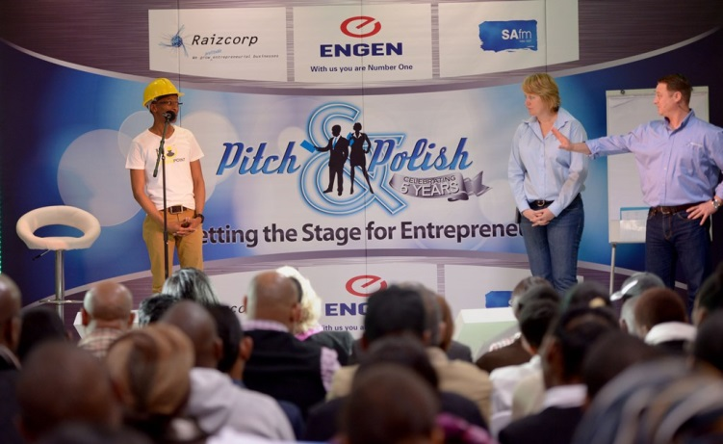

Business Competition and Workshop in Rustenburg – Call for Entries
Free Entrepreneurial Training: Register NOW

Are you hungry for change? Let 2015 be the year of change for your business or business idea! Fast-track your entrepreneurial journey by participating in the ENGEN Pitch & Polish programme, where you will learn to polish your pitch. It’s time for your voice to be heard.
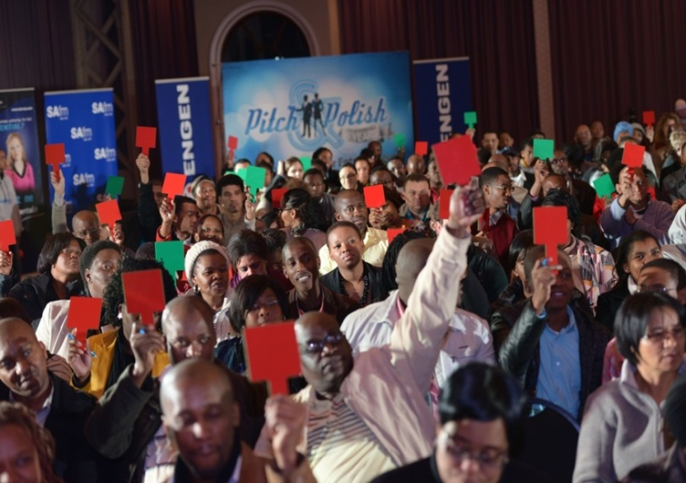
Registrations for the 2015 ENGEN Pitch & Polish programme is officially open and looking to discover the nation’s most promising local entrepreneurs. Great things are in store for all participants who take this opportunity to explore their pitch, and are prepared for new opportunities; along with sponsors Engen Petroleum Ltd and Royal Bafokeng Enterprise Development (RBED), business incubator Raizcorp, national media partner SAfm, as well as programme partners QuadPara Association of South Africa and NYDA.
ENGEN Pitch & Polish, along with its partners, want entrepreneurs to have the ability to access funding through the ability to share your business or business idea effectively. Combined with understanding the fundamentals of business, your polished pitch is the gateway to your success. Plus you stand a chance to win prizes and money!

Ian Venter, Acting Head of Department for Royal Bafokeng Enterprise Development, said the following about their involvement, “RBED is proud to be a co-sponsor for the Rustenburg leg of the ENGEN Pitch & Polish workshop and competition to facilitate access by Bafokeng entrepreneurs into this fabulous opportunity”.
During the vibrant and dynamic learning experience, both delegates and competitors will have the chance to finesse their pitch and improve their business offering. This annual event, now in its sixth year, has impacted thousands and continues to reach and teach eager entrepreneurs.
Are you ready?
- For a FREE one-day entrepreneurial event?
- To think deeper about how your business is going to grow?
- To think smarter?
- To find gaps in your market?
- To have your pitch perfected?

If you are the entrepreneur waiting to be discovered, 2015 is the year that ENGEN Pitch & Polish changes your pitch so you can actualise the opportunities that come your way.
Register now to attend or compete at the FREE Rustenburg event happening on Saturday 17 October. Sms PITCH to 45901 (charged at R1.50 per sms) or register online at www.pitchandpolish.com.
It’s your year for change and opportunities!

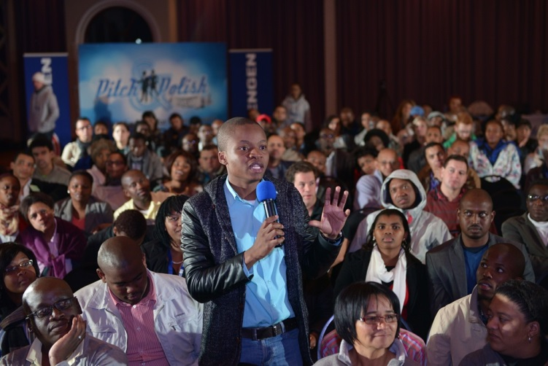

QUIZ BLOCK

Take Part In Our Quiz And Win Awesome Prices!! Two winners will be randomly selected.

- When was the official launch of ED Centre?
- Who is the head of ABSA Business Banking?
- Which Bafokeng Village is Kagiso residing from?

To Enter Please Send Your Answers To
Tebogo.sedumedi@bafokeng.com
Or call us on: (014) 589 3000
QUIZ BLOG
Publication of the RBED

EDITOR
Tebogo Sedumedi

PRODUCTION TEAM
Tebogo Sedumedi, Ian Venter, Ratanang Selomane, Masisi Tumagole & Talent Muzambi

PHOTOGRAPHERS
Ratanang Selomane & Talent Muzambi

THIS ISSUE’S CONTRIBUTORS
Ian Venter, Ratanang Selomane, Tebogo Sedumedi, Masisi Tumagole & Talent Muzambi

RBED Contacts
014 589 3000
admin@bafokengdevelopment.com

